Supplementary Information

Unraveling the Diversity of Arc Volcanism and Deep Low-frequency Tremors in Southwest Japan from Numerical Modeling

Goeun Ha1,2, Changyeol Lee3,* and YoungHee Kim1,2*

1Center for Deep-Surface Coupling of Earth, Seoul National University

1 Gwanak–ro, Gwanak–gu, Seoul, Republic of Korea 08826

2School of Earth and Environmental Sciences, Seoul National University

1 Gwanak–ro, Gwanak–gu Seoul, Republic of Korea 08826

3Department of Earth System Sciences, Yonsei University

50 Yonsei–ro Seodaemun–gu, Seoul, Republic of Korea 03722

*Correspondence to: changyeol.lee@yonsei.ac.kr, younghkim@snu.ac.kr

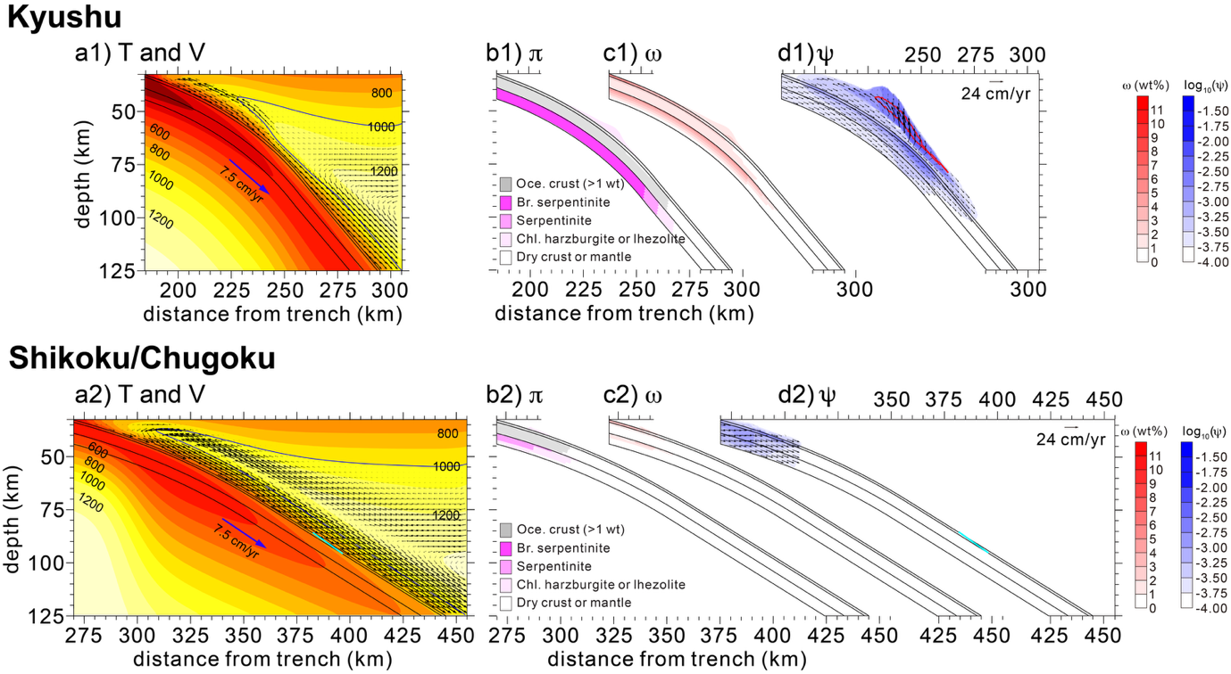

Supplementary Fig. 1. Model results for Kyushu (a1-d1) and Shikoku/Chugoku (a2-d2) at 14.5 Ma. (a1-a2) Distributions of temperature (T) and velocity (V). Black lines in the subducting plate indicate boundaries of the basaltic oceanic crust, gabbroic oceanic crust, and the hydrated portion of the lithospheric mantle. The cyan line in the basaltic oceanic crust indicates the wet basalt solidus (750°C). The thick blue contour in the mantle wedge represents the 1000°C isotherm. (b1-b2) Distributions of major hydrous mineral phases (π) (e.g., Br. serpentinite (brucite-bearing serpentinite), serpentinite, and Chl. harzburgite or lherzolite (chlorite-bearing harzburgite or lherzolite) in the lithospheric mantle and mantle wedge. (c1-c2) Distributions of bound water (ω) in the crust, lithospheric mantle, and mantle wedge. (d1-d2) Distributions of free water (ψ) in the oceanic crust and hydrated lithospheric mantle, and mantle wedge. The fluid velocity is shown by black arrows. The red contour in the mantle wedge represents the potential flux melting zone (bound water > 0.1 wt% and T > 1000°C).

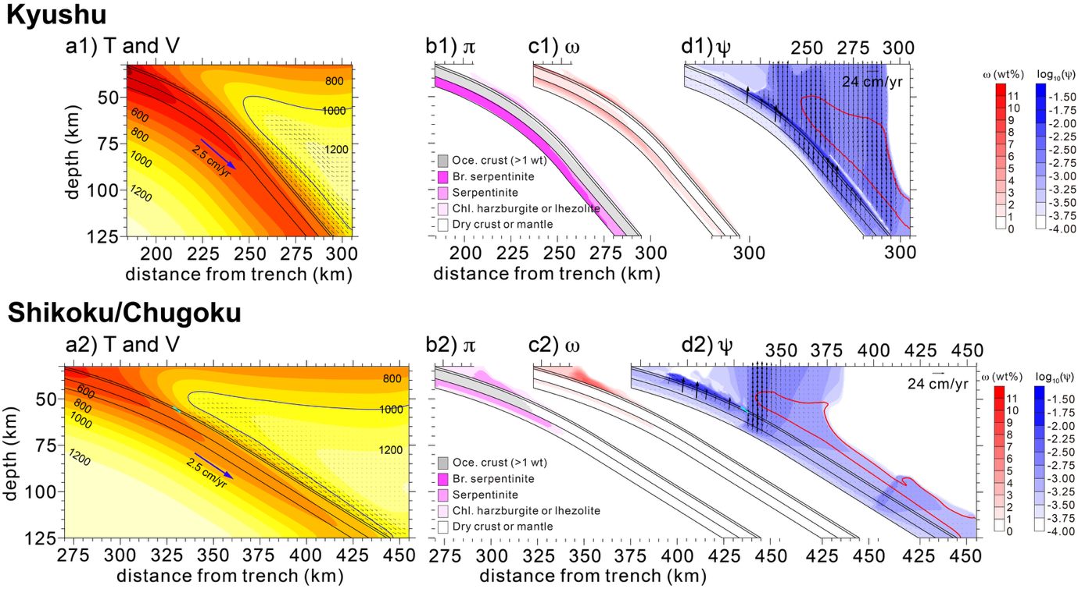

Supplementary Fig. 2. Model results for Kyushu (a1-d1) and Shikoku/Chugoku (a2-d2) at 12 Ma. The figure notations are the same as those in Supplementary Fig. 1.

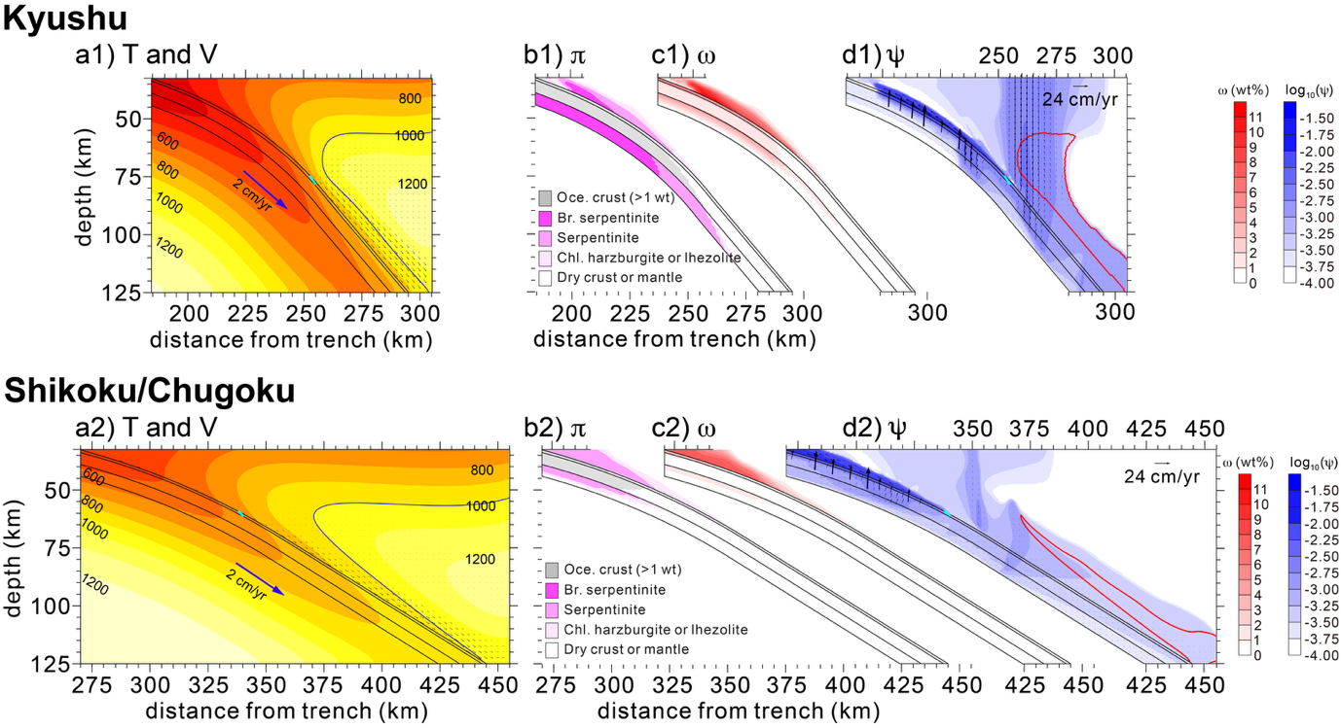

Supplementary Fig. 3. Model results for Kyushu (a1-d1) and Shikoku/Chugoku (a2-d2) at 8 Ma. The figure notations are the same as those in Supplementary Fig. 1.

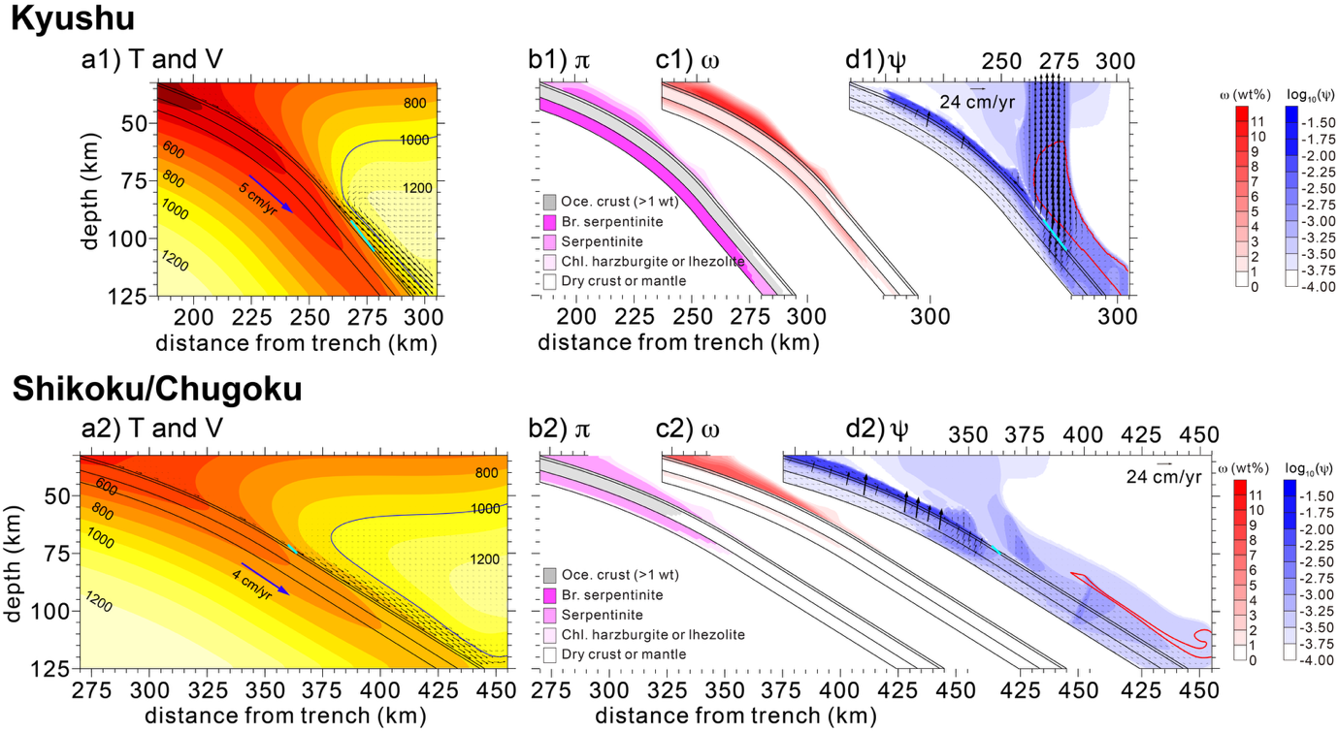

Supplementary Fig. 4. Model results for Kyushu (a1-d1) and Shikoku/Chugoku (a2-d2) at 3 Ma. The figure notations are the same as those in Supplementary Fig. 1.

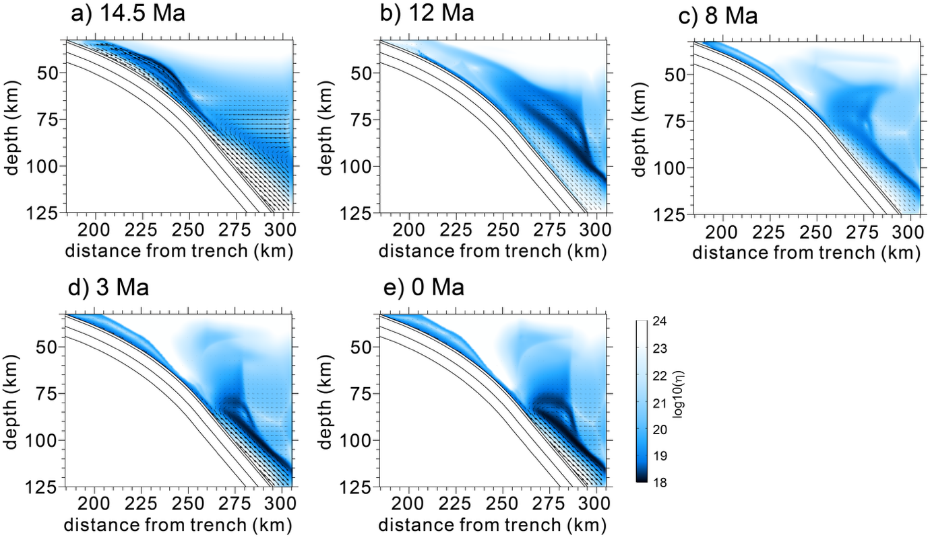

Supplementary Fig. 5. Distribution of viscosity and velocity for Kyushu at 14.5, 12, 8, 3, and 0 Ma. Black lines in the subducting plate indicate boundaries of the basaltic oceanic crust, gabbroic oceanic crust, and the hydrated portion of the lithospheric mantle.

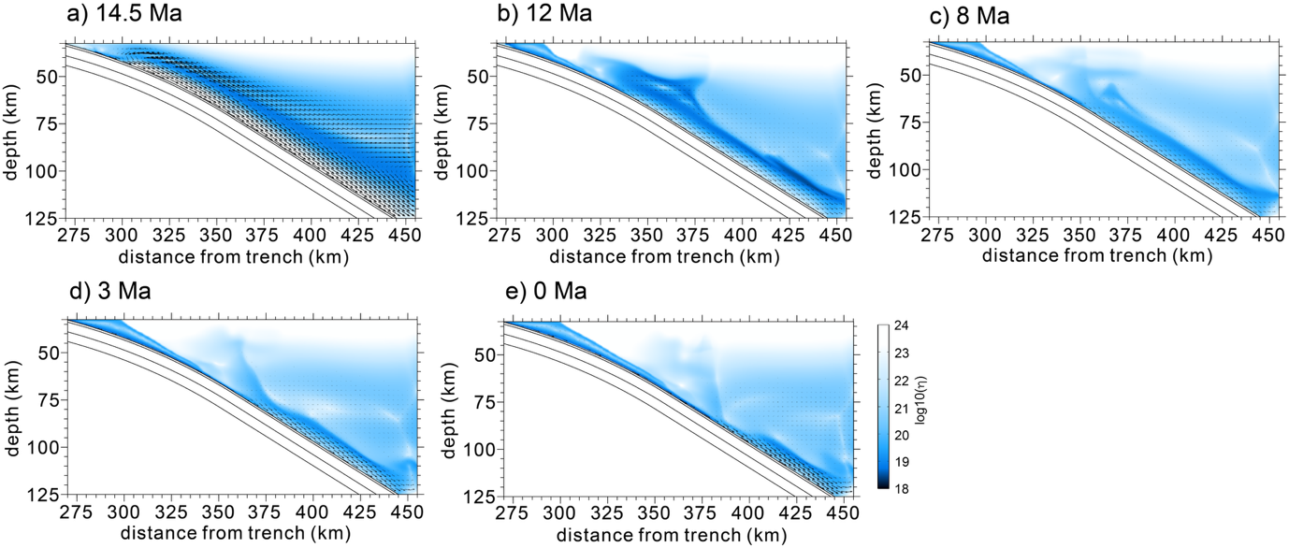

Supplementary Fig. 6. Distribution of viscosity and velocity for Shikoku/Chugoku at 14.5, 12, 8, 3, and 0 Ma. The figure notations are the same as those in Supplementary Fig. 5.

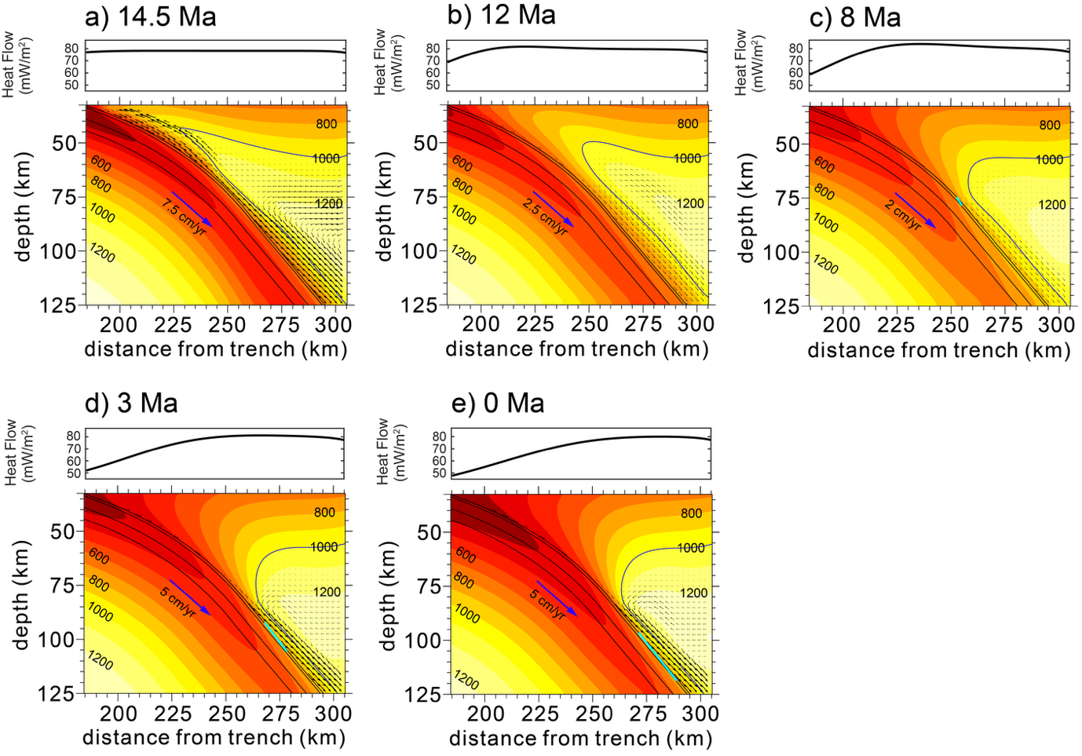

Supplementary Fig. 7. Model results for Kyushu at 14.5, 12, 8, 3, and 0 Ma. The upper subplots show the surface heat flow, derived from the thermal structure presented in the lower subplots. The figure notations for the lower subplots are the same as those in Supplementary Fig. 1.

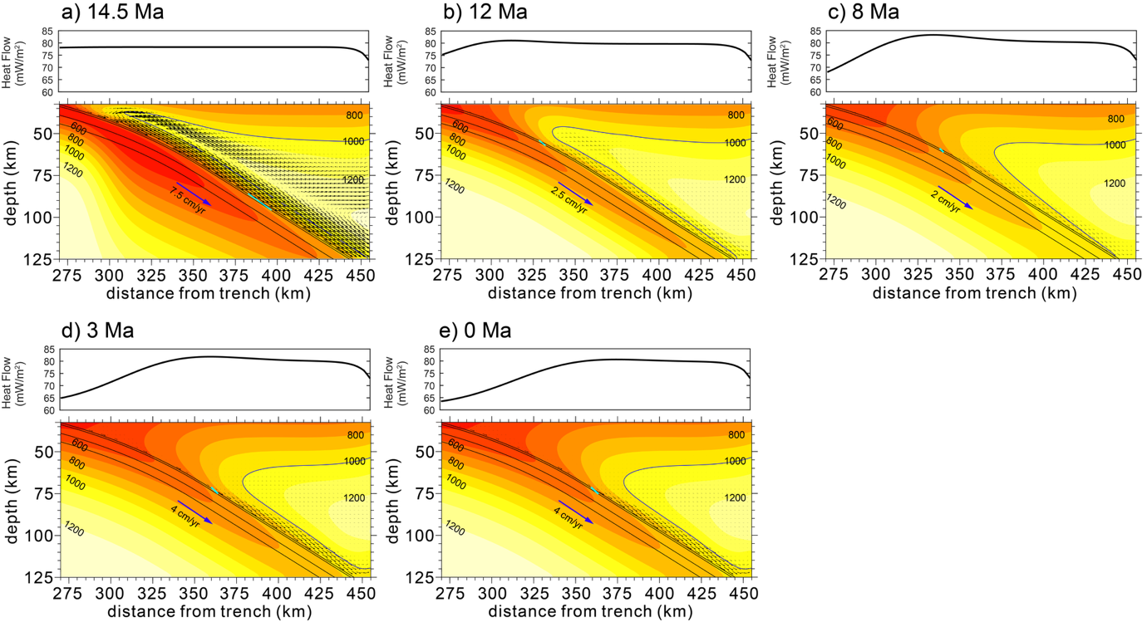

Supplementary Fig. 8. Model results for Shikoku/Chugoku at 14.5, 12, 8, 3, and 0 Ma. The figure notations are the same as those in Supplementary Fig. 7.

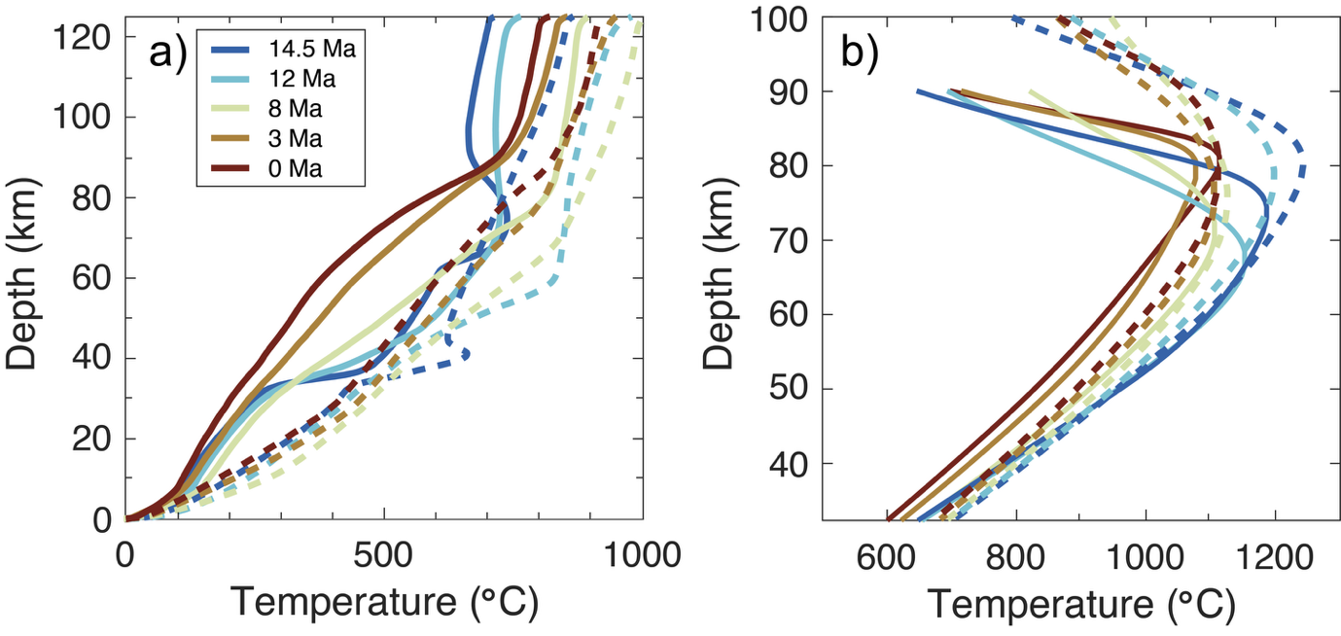

Supplementary Fig. 9. Temperature profiles extracted a) along the slab surface and b) vertically beneath the arc at 14.5, 12, 8, 3, and 0 Ma. Solid and dashed lines represent the values obtained from Kyushu and Shikoku/Chugoku, respectively.

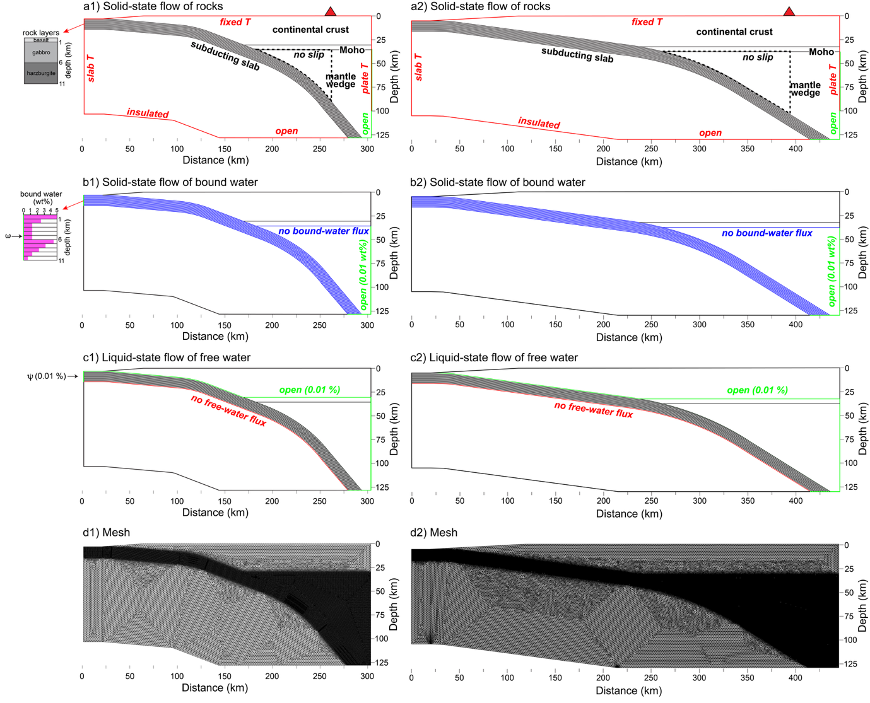

Supplementary Fig. 10. Geometry, boundary conditions, and mesh used in the numerical models at (a1)-(d1) Kyushu and (a2)-(d2) Shikoku/Chugoku. (a1), (a2) Boundary conditions for the solid-state flow of rocks. Red triangle indicates the location of arc volcano and the region enclosed by the black dashed line indicates the sub-forearc mantle wedge. To allow a spontaneous development of the overlying continental lithosphere, a no-slip boundary condition is imposed along the continental Moho. (b1), (b2) Boundary conditions for the solid-state flow of bound water. The depth-dependent distribution of the bound water (ω) is incorporated into the subducting slab through the trench-side vertical boundary. (c1), (c2) Boundary conditions for the liquid-state flow of free water (ψ). A 5-km-thick low permeability layer of the gabbroic continental crust is assigned to the lower continental crust, with the open boundary at the top. (d1), (d2) The entire model domains consist of unstructured triangular elements with mesh refinements in the hydrated portion of the subducting slab and at the base of the mantle wedge.

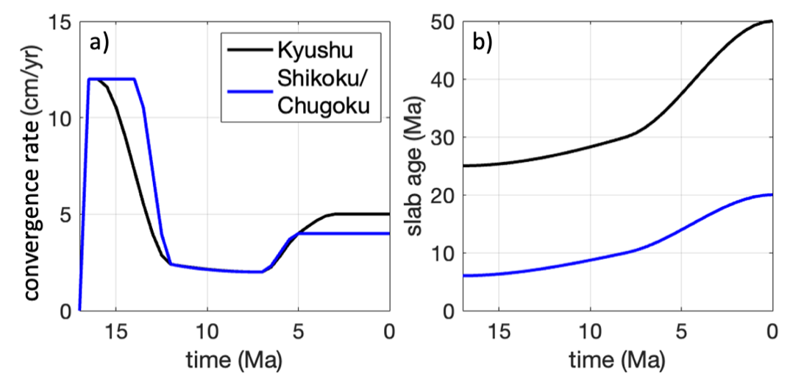

Supplementary Fig. 11. (a) Convergence rate and (b) slab age at the trench from 17 to 0 Maref.1-3 used for the model calculations. The values were interpolated using a piecewise cubic spline.

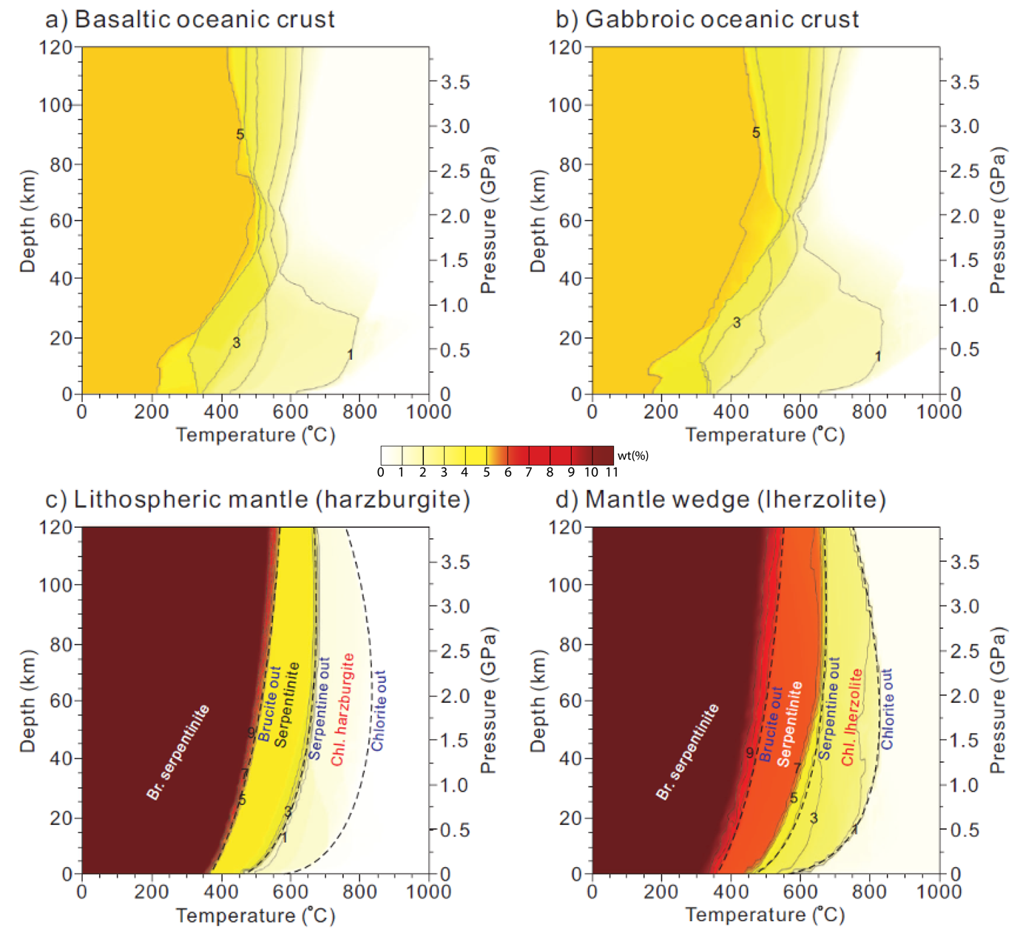

Supplementary Fig. 12. Phase diagrams showing bound-water solubilities for the basaltic oceanic crust, gabbroic oceanic crust, lithospheric mantle, and mantle wedge. (a) Bound-water solubility of (a) the basaltic oceanic crust, (b) the gabbroic oceanic crust, (c) the lithospheric mantle (harzburgite), and (d) the mantle wedge (lherzolite) of the subducting slab. The numbers in each panel represent water solubilities in wt%. Br. serpentinite and Chl. harzburgite represent brucite-bearing serpentinite and chlorite-bearing harzburgite, respectively. The black dashed lines in panels (c) and (d) correspond to brucite-, serpentine-, and chlorite-out phase boundaries. All panels were adapted under CC BY-NC 4.0 from Supplementary Fig.4ref.4.

Supplementary Table 1. Model parameters

|  |  |
| --- | --- |
| **Parameters for the solid rocks** | |
| Solid (rock) density (kg m-3) | 3300 |
| Specific heat at constant pressure *Cp* (J kg-1 K-1) | 1000 |
| Thermal conductivity *k* (W m-1 K-1) | 3.0 |
| Domain depth *D* (m) | 125×103 |
| Thermal diffusivity (m2 s-1) | 9.0909×10-7 |
| Mantle temperature difference $\text{∆T}$ (K) | 1623 |
| Net mantle adiabat (K km-1) | 0.35 |
| Radiogenic heat production *H* (J kg-1 s-1) |  |
| Oceanic crust (basaltic and gabbroic crusts) | 27×10-12 |
| Continental crust | 525×10-12 |
| Mantle | 1.5×10-12 |
| **Parameters for shear viscosity** | |
| Background mass fraction of bound water *ωr* (∙) | 10-4 |
| Shear modulus *μ* (Pa) | 8.0×1010 |
| Pre-exponent factor *A* |  |
| Olivine, diffusion creep (s-1)  Olivine, dislocation creep (s-1)  Serpentine, dislocation creep (s-1) | 8.7×1015  3.5×1022  4.474×10-38 |
| Burgers vector *b* (m) | 5×10-10 |
| Grain size *d* (m) | 2×10-3 |
| Grain size exponent *m* (∙) | 2.5 |
| Stress exponent *n* |  |
| Olivine, dislocation creep $n_{ol}$ (∙) | 3.5 |
| Serpentine, dislocation creep $n_{serp}$ (∙) | 3.8 |
| Activation energy *E* |  |
| Olivine, diffusion creep (J mol-1) | 300×103 |
| Olivine, dislocation creep (J mol-1) | 540×103 |
| Serpentine, dislocation creep (J mol-1) | 8.9×103 |
| Activation volume *V* |  |
| Olivine, diffusion creep (m3 mol-1) | 6.0×10-6 |
| Olivine, dislocation creep (m3 mol-1) | 2.0×10-5 |
| Serpentine, dislocation creep (m3 mol-1) | 3.2×10-6 |
| Reference viscosity $η_{0}$ at 125 km depth (Pa s) | 7.8053×1019 |
| Activation function of serpentine viscosity *f($ω$)* (∙) | 2000 at $ω$ = 0 500 at $ω$ = 1 wt% 1 at $ω$ > 2.153 wt% |
| **Parameters for bound and free water** | |
| Free-water density (kg m-3) | 1000 |  |
| Free-water viscosity $η_{f}$ (Pa s) | 1 |
| Artificial diffusivity of free water (m2 s-1) | 9.0909×10-9 |
| Artificial diffusivity of bound water (m2 s-1) | 9.0909×10-9 |
| Gravitational acceleration (m s-2) | 9.81 |
| Background volume fraction of free water (porosity) (∙) | 10-4 |
| Geometrical factor of grain $C_{d}$ (∙) | 270 |
| Dehydration length *l* (km) | 1.25 |

**References**

1 Kimura, J.-I., Stern, R. J. & Yoshida, T. Reinitiation of subduction and magmatic responses in SW Japan during Neogene time. *Geol. Soc. Am. Bull.* **117**, 969-986, https://doi.org/10.1130/b25565.1 (2005).

2 Tatsumi, Y., Suenaga, N., Yoshioka, S., Kaneko, K. & Matsumoto, T. Contrasting volcano spacing along SW Japan arc caused by difference in age of subducting lithosphere. *Sci. Rep.* **10**, 15005, https://doi.org/10.1038/s41598-020-72173-6 (2020).

3 Seno, T., Stein, S., & Gripp, A. E. A model for the motion of the Philippine Sea plate consistent with NUVEL‐1 and geological data. *J. Geophys. Res. Solid Earth***98**, 17941-17948. https://doi.org/10.1029/93JB00782 (1993).

4 Lee, C., & Kim, Y. Understanding subduction infancy to mature subduction in Southwest Japan via the self-consistent formation of a weak slab interface. *Sci. Rep.* **13**, 21425, https://doi.org/10.1038/s41598-023-48746-6 (2023).